Movie Ticket Booking System
A Command-Line Booking System Implemented in C
Project Report
CSC 1031 - Software Development Fundamentals
University of Sri Jayewardenepura


Group Members
T.S.P.Fernando [AS20250397]
A.J.M.H.M.Aberathne [AS20250494]
H.D.J.Kaveesha [AS20250508]
M.P.G.H.Pathirana [AS20250566]
K.T.D.K.H.Wijethunga [AS20250647]
Submitted Date: [24/07/2026]

Introduction
Cinemas that rely on a paper diary to track bookings run into the same problems every weekend: double booked seats, miscounted takings, and no quick way to check whether a seat is still free. The Movie Ticket Booking System is a command line C application that removes that friction, letting a small cinema manage seat reservations, pricing, and revenue for a fixed set of movies and showtimes entirely in memory, with no database or external dependency.
The project was built with the standard C library only (no external dependencies) and compiles with a single gcc *.c -o booking command.
The system is menu-driven: on start-up it builds a fixed catalogue of three movies and their showtimes (The system models three movies, each with two showtimes, and every showtime has its own 5×10 seat grid.), then loops on a role menu (Customer / Admin / Exit). Customers can view showtimes, view seat maps, book seats, and cancel bookings; Admins get those features plus search and a revenue report, gated behind a login with a limited number of attempts.

Team Contribution Summary
The table below lists each member, their assigned module(s), and a short description of their specific contribution to the project.
Member | Module(s) | Contribution
T.S.P.Fernando | Auth,c/auth.h, config.h, README.md, main.c | Project planning, repository setup, backend development
A.J.M.H.M.Aberathne | pricing.c / pricing.h | Frontend development and UI design
H.D.J.Kaveesha | movie.c/movie.h | Database design and implementation
M.P.G.H.Pathirana | display.c / display.h, seat.c/seat.h | Testing, debugging, and documentation
K.T.D.K.H.Wijethunga | booking.c/ booking.h, input.c/input.h | booking/input files

Design Overview

1. Data Structures
- Seat (seat.h): the smallest stateful object in the system - an isBooked flag, customerName, pricePaid, and isStudent/isSenior flags recording which discount applied to that specific seat.
- Showtime (movie.h): owns a full NUM_ROWS × SEATS_PER_ROW grid of Seat, plus a time label and running totals ticketsSold and totalRevenue.
- Movie (movie.h): a title paired with a fixed-size array of Showtime. initMovies() builds the hardcoded catalogue of three movies.

2. Pricing & Discount Logic
Seat Tier | Rows | Base Price
Regular | A – B | Rs. 500.00
Premium | C – D | Rs. 750.00
VIP | E | Rs. 1000.00

- Student: 10% off base price. Senior citizen: 20% off base price. Only one of these two categories can apply per booking.
- Group: an additional 10% off when 4 or more seats are booked in a single transaction; this combines additively with the category discount.
Final price = basePrice × (1 − (category% + group%) / 100). Example: a Premium seat (Rs. 750) booked by a student as part of a 5 seat group booking gets 10% + 10% = 20% off, giving 750 × 0.80 = Rs. 600.00. On cancellation, cancelSeat() subtracts the seat's stored pricePaid from totalRevenue and decrements ticketsSold before clearing the seat, so refunds are never left counted in the revenue total.

3. Module Connections
The list below shows how the source files call into one another, from the top-level menu loop down to the lowest-level lookups.
- main.c - role/menu loops; wires user choices to booking, display, and input.
- main.c calls readInt() / readLine() / readChar() in input.c for all validated input.
- main.c calls authenticateAdmin() in auth.c to gate the Admin Menu.
- main.c calls printShowtimesList(), printSeatMap(), printRevenueReport() in display.c for all screen output.
- main.c calls bookSeat(), cancelSeat(), searchByName(), searchBySeat() in booking.c for all booking operations.
- booking.c calls calculateSeatPrice() in pricing.c to obtain the final price for a seat.
- booking.c and display.c both call seatTierForRow(), seatTierSymbol(), isValidSeatPosition() in seat.c for tier lookups and position validation.
- movie.c's initMovies() builds the Movie / Showtime / Seat data that every module above operates on.

Screenshots & Program Walkthrough
This section walks through a single continuous run of the compiled program, from launch to exit, with a placeholder for each screenshot that should be captured directly from the terminal or IDE.

Screenshot 1: The main menu — the role menu shown at start-up.
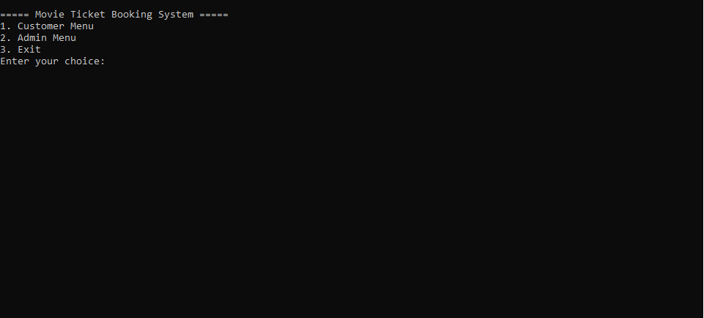

Screenshot 2: The seat map before any bookings are made.
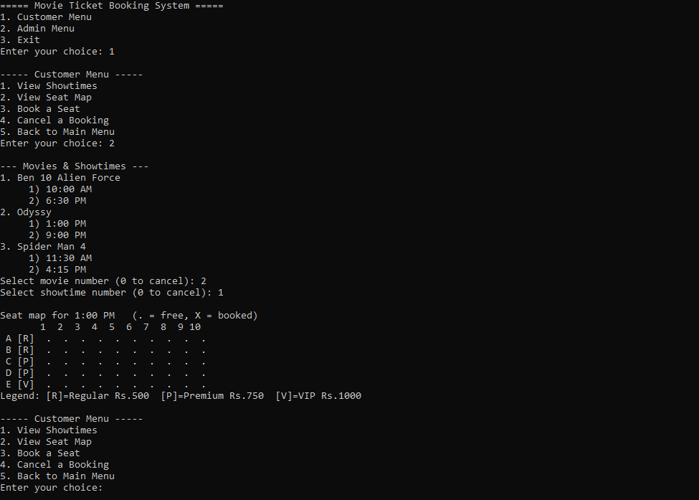
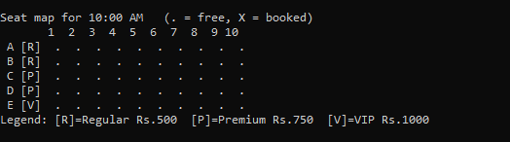

Screenshot 3: A successful seat booking, showing the calculated price.
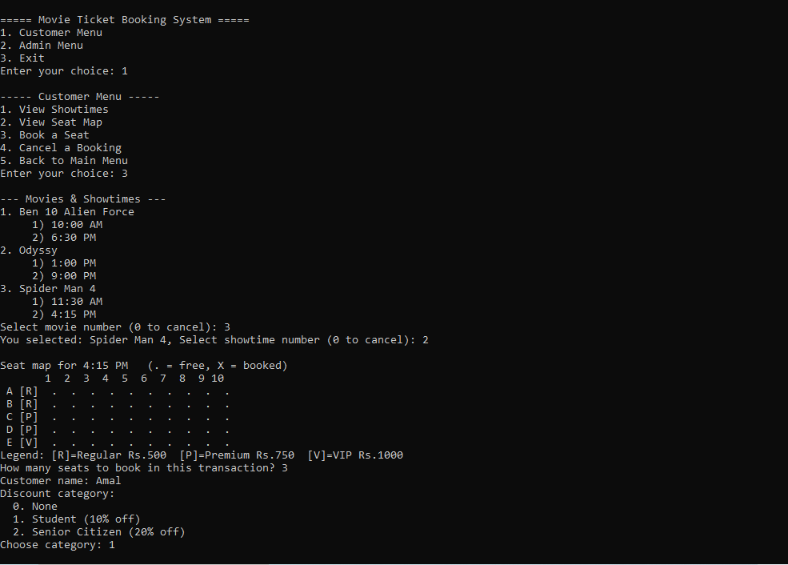
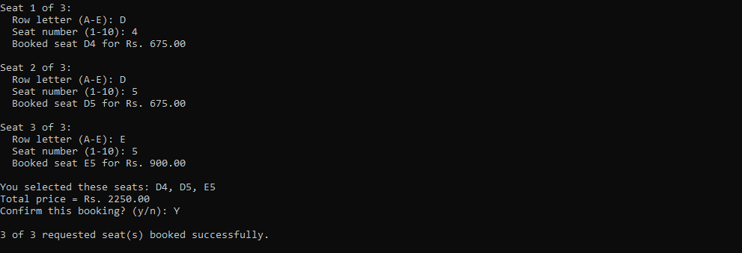

Screenshot 4: An attempt to book an already-taken seat, showing the error message (no crash).
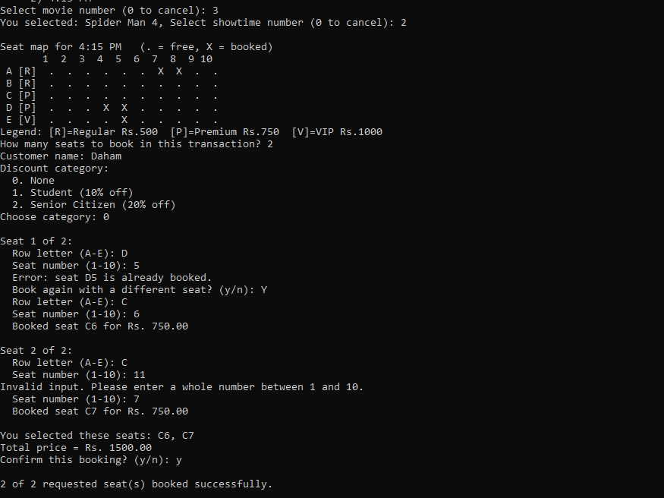

Screenshot 5: A booking cancellation, showing the seat becoming free again.
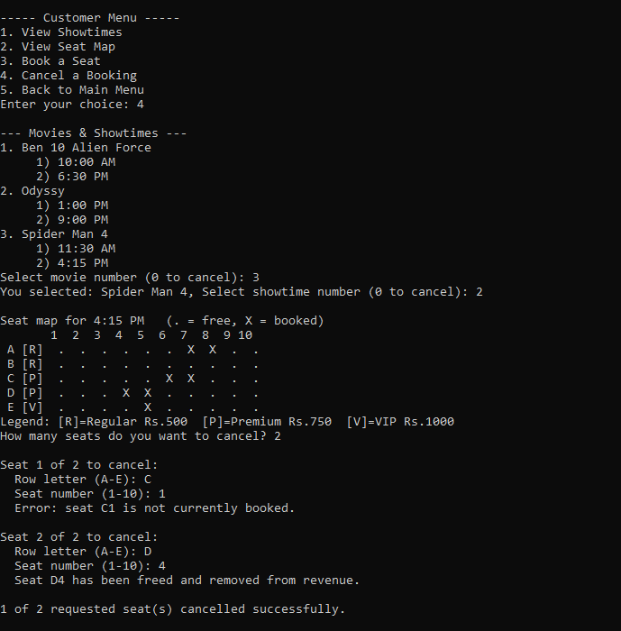
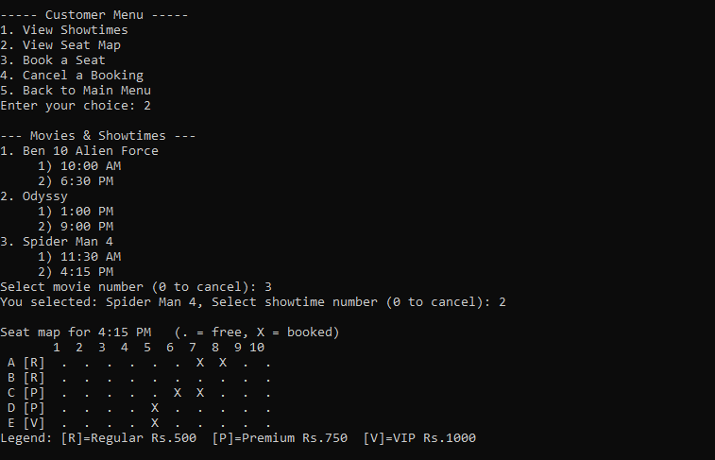

Screenshot 6: A search result for a booking by name or seat number.
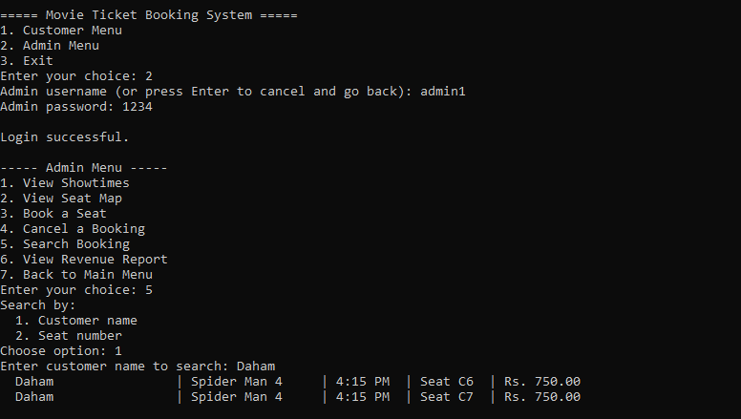

Screenshot 7: The revenue report screen, showing totals updating correctly.

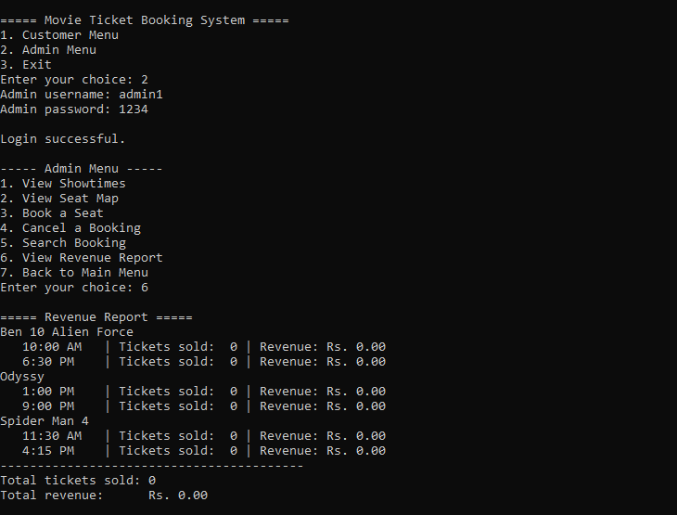
After booking:
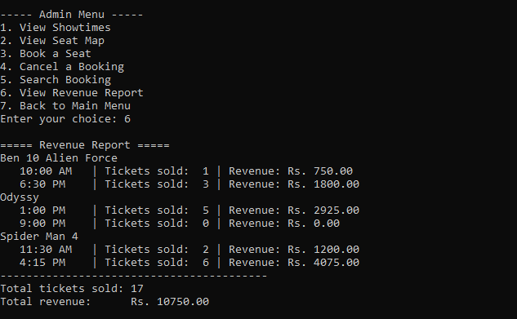

Challenges & How They Were Solved

1. Revenue Not Updating on Cancellation
Problem: an early version of cancelSeat() cleared the seat's isBooked flag without subtracting its pricePaid from the showtime's totalRevenue, so cancelled seats stayed counted in the revenue report.
Solution: the fix subtracts pricePaid and decrements ticketsSold before clearing the seat's fields, and a book-then-cancel regression check was added to the team's manual test list. Lesson: the refund calculation must happen before the data it depends on is reset.

2. Crash Prone Input Handling
Problem: an early version read menu choices directly with scanf("%d", ...), which left the input stream in an inconsistent state whenever a letter was typed instead of a number, causing the same prompt to loop without the program ever making progress.
Solution: all input was centralised into input.c, reading a full line with fgets() and parsing it with sscanf(), so a bad line is simply discarded and re-prompted.

3. Merge Conflicts on Shared Headers
Problem: config.h and movie.h are depended on by almost every module, so two members editing them at once produced conflicts that were riskier to resolve than an ordinary .c file conflict, and one early conflict was resolved carelessly and briefly broke the build.
Solution: the team agreed to announce any change to a shared header before pushing, and to resolve conflicts in those files together rather than individually.

GitHub Collaboration Summary
Screenshot : Repository commit history .
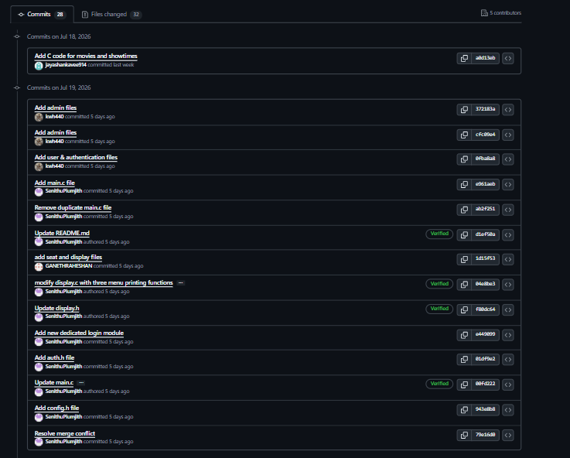
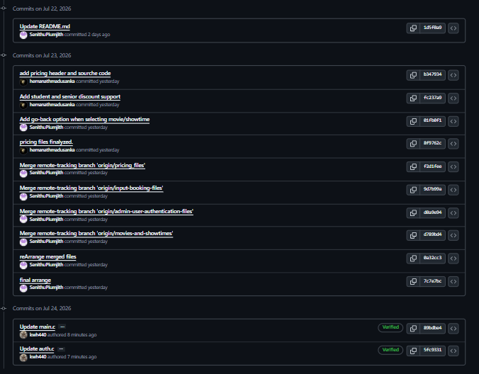

The team used a shared GitHub and each member cloned the repository, worked on short lived feature branches (one branch per module or significant change), and pushed commits. Pull requests were used to merge features branch into main. A lightweight issues list tracked outstanding bugs and pending features and This workflow kept main build able for most of development and is one the team intends to reuse in future group projects.

